Authorship Guidelines – Rocky Vista University

Amanda Brooks, PhD
Director of Research and Scholarly Activity
and
David Forstein, DO
President, CEO & Provost
April 14, 2022

At Rocky Vista University, it is our goal to increase the amount and quality of research and scholarly activity. We desire to have all faculty involved in presentations and publications, and encourage faculty to recruit their colleagues to assist with research and manuscript preparation. We especially want to provide students with opportunities to earn authorship. Therefore, clarity about the contributions that qualify for authorship is necessary.
Authorship for any manuscript/abstract/poster/presentation is beneficial for all faculty, staff, and students. Peer reviewed dissemination of research and scholarly activity is well recognized in academe to be a reflection of one’s intellect and reputation. Additionally, authorship is necessary for faculty rank promotion and may be beneficial for our student’s residency applications. Based on the high stakes, authorship can be contentious [1]; therefore, these guidelines have been established to help prevent disputes, clarify who qualifies for authorship, and determine the most equitable order of authors. The following is a suggested protocol for authorship for manuscripts/abstracts/posters/presentations as derived and synthesized from the Vancouver Group’s criteria for authorship as summarized by International Committee of Medical Journal Editors (ICMJE) [2], [3] and the NIH guidelines for authorship contributions.

The ICMJE recommends that authorship be based on the following 4 criteria:
- Substantial contributions to the conception or design of the work; or the acquisition, analysis, or interpretation of data for the work; AND
- Drafting the work or revising it critically for important intellectual content; AND
- Final approval of the version to be published; AND
- Agreement to be accountable for all aspects of the work in ensuring that questions related to the accuracy or integrity of any part of the work are appropriately investigated and resolved.

There are contributions that do not merit inclusion as an author but instead inclusion as an acknowledgement [3], [4]. Examples of activities that alone (without other contributions) do not qualify a contributor for authorship are acquisition of funding; general supervision of a research group or general administrative support; and writing assistance, technical editing, language editing, and proofreading. They may also include items such as data collection, providing data, providing patients or animals, providing funding, or providing administrative support [4], [5]. The National Institutes of health provided a useful visual for authorship reproduced here from their guide for the ethical conduct of research (Figure 1).

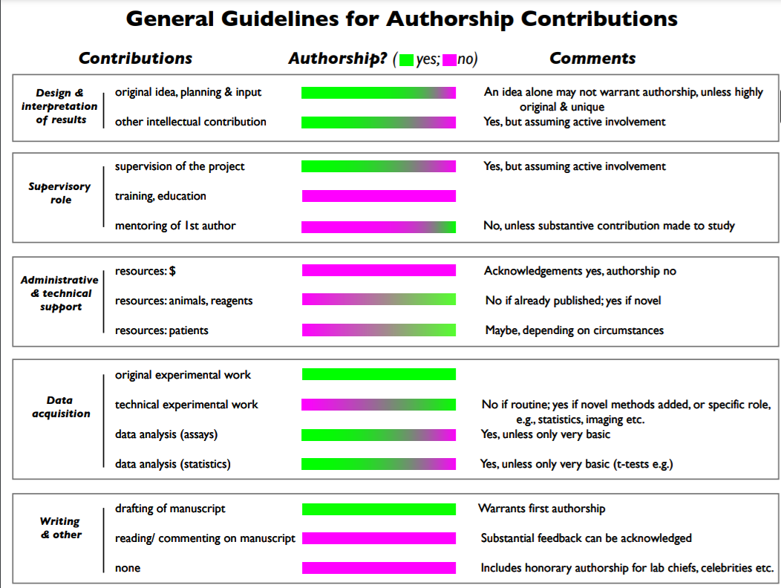
Figure 1. General authorship guidelines from the NIH (https://oir.nih.gov/sites/default/files/uploads/sourcebook/documents/ethical_conduct/guidelines-conduct_research.pdf)
The order of authorship should be decided upon by the fraction of work performed and agreed upon by all authors, thus making it easy for the reader to understand the contribution each author provided to the manuscript [6]. Ahmed and associates [4] addressed this issue and developed an authorship scale (Table 1). We advocate authors using this scale when preparing the manuscript to provide some objectivity in attributing authorship, bearing in mind that authorship and author order can be fluid. If the Vancouver group guidelines have been met, authorship order should be determined according to the scale put forth by Ahmed et al. A person must have a score in four of the seven items and a minimum total score of 11 to be included as an author. The definition of minimal, some, and significant should be defined by the authorship team as it may vary based on discipline and specific topic.
Minimal:
Some:
Significant:

Table 1. Authorship Scale: Determining individual contribution for authorship (minimal (1 point), some (3 points), significant (5 points), public responsibility (1 point)). A single scale should be filled out for each author to determine the order. Modified from Ahmed et al.
Item | Author 1 | Author 2 | Author 3 | Author 4 | Author 5 | Author 6
Conception
Experimental Design
Experimental Execution
Data Analysis/ Interpretation
Drafting the Article
Revising/ Reviewing the Article
Public responsibility (score 1 for yes and 0 for no)
Total
Author signature

Please check the box to indicate if the writing center reviewed the manuscript.

Please check the box to indicate if you have had extensive help (e.g., literature search or editing) from the library.

A couple of additional notes on authorship order:
- All authors should be involved when filling out the authorship table and defining minimal, some, and significant at the beginning of manuscript preparation and again prior to submission.
- In case of a tie for first authorship, the score for conception should be more heavily considered or a dual authorship can be considered if allowed by the journal.
- There are times when either the first or second author would prefer to be the last (sometimes referred to as the ‘senior’) author. Based on point totals, the first or second author should have that option. This is especially useful when working with students, residents, or junior faculty.
- There are times when authorship order for a meeting presentation (oral or poster) is different than for a manuscript, based on post-meeting contributions to the final project.
- We recommend that each research project begin with a discussion of who will lead the project, assign the tasks, and keep things on schedule. Often this person will be the first, or senior author.
- Any contributors to a publication that do not reach the score of 11 in four or more of the categories above should be considered for an acknowledgement.

If disputes arise over authorship, the Director of Research, in consultation with appropriate senior leadership, will hear from all involved parties and render a decision. The authorship table with signatures from all authors, indicating their agreement and willingness to accept responsibility for the publication, should be submitted to the director of research with any request to pay for publication.

References:
[1] D. B. Resnik, E. Smith, Z. Master, and M. Shi, “Survey of Equal Contributions in Biomedical Research Publications,” Account. Res., vol. 27, no. 3, pp. 115–137, Apr. 2020, doi: 10.1080/08989621.2020.1722947.
[2] “ICMJE | Recommendations | Defining the Role of Authors and Contributors.” http://www.icmje.org/recommendations/browse/roles-and-responsibilities/defining-the-role-of-authors-and-contributors.html (accessed Sep. 26, 2021).
[3] G. Pruschak, “What Constitutes Authorship in the Social Sciences?,” Front. Res. Metr. Anal., vol. 6, p. 655350, Mar. 2021, doi: 10.3389/frma.2021.655350.
[4] S. M. Ahmed, C. A. Maurana, J. A. Engle, D. E. Uddin, and K. D. Glaus, “A method for assigning authorship in multiauthored publications,” Fam. Med., vol. 29, no. 1, pp. 42–44, Jan. 1997.
[5] International Committee of Medical Journal Editors, “Uniform requirements for manuscripts submitted to biomedical journals,” N. Engl. J. Med., vol. 336, no. 4, pp. 309–315, Jan. 1997, doi: 10.1056/NEJM199701233360422.
[6] D. Rennie, V. Yank, and L. Emanuel, “When authorship fails. A proposal to make contributors accountable,” JAMA, vol. 278, no. 7, pp. 579–585, Aug. 1997, doi: 10.1001/jama.278.7.579.

