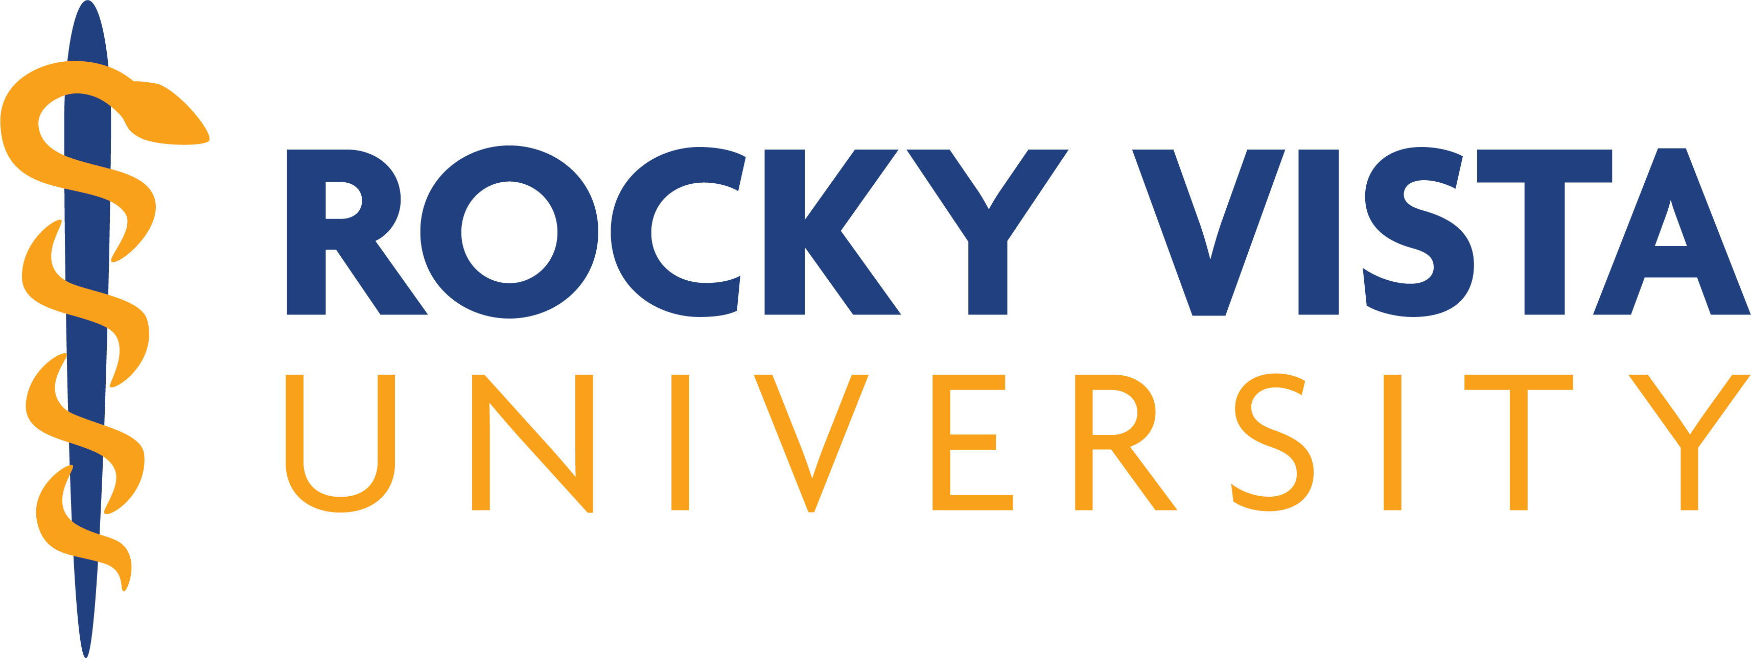
OFFICE of COMPLIANCE & QUALITY ASSURANCE (ORC-QA)
INSTITUTIONAL REVIEW BOARD (IRB)

IRB Outside Research Authorization Agreement

When an RVU employee/faculty/student is involved in a human subjects research project that has or will be approved by an IRB sponsored by an alternate (outside) institution, the RVU IRB requires the signing of an “Outside Research Authorization Agreement” form by the other institution’s IRB.

Address any questions to the RVU Office of Research Compliance & Quality Assurance (ORC-QA) at 720.874.2481.

Institution Relying on the Designated IRB:
Name: Rocky Vista University

IRB Registration #: 0006156 Federalwide Assurance (FWA) #: 00020371

The Officials signing below agree that Rocky Vista University may rely on the Reviewing Institution’s IRB for applicable education, review of research, and continuing oversight of the human subjects research described below.

Institution Providing IRB Review and approval (Designated IRB):
Name:

IRB Registration #: Federalwide Assurance (FWA) #, if any:

This agreement is limited to the following specific projects:

Name of Project:

Name of Principal Investigator:
RVU Affiliated Investigator(s): __________________________________________________________

Sponsor or Funding Agency: Award Number, if any:

The review performed by the designated IRB will meet the human subject protection requirements of RVU’s IRB, which comply with all Federal, State, and Local regulations. The IRB at the Reviewing Institution will report its findings and actions to appropriate officials at RVU. Relevant minutes (or portions) of IRB meetings will be made available to RVU upon request. RVU remains responsible for ensuring compliance with the determinations of the Reviewing Institution’s IRB. This document must be kept on file by both parties and provided to OHRP upon request.

Signature of Signatory Official (Reviewing Institution):

Signature Date
Name of Signing Official:
Title:
Institution Address:

Name of RVU IRB Official: Dr. Brad Thornock
Title: Chair of IRB, Rocky Vista University
Institution Address: 8401 S. Chambers Rd.
Englewood, CO 80112
720-874-2481 (IRB Compliance Office)

